Name : Shirsath Sanket Dilip Roll No: 69
Class : TE Div : B Branch : COM
Assignment : Virtual Assignment 1
Title : Fabrication of Cables
Aim :
  - To practise the colour code for different cables.
  - Observe the Lan Tester and make the decision accordingly.
Theory:
A twisted pair consists of two insulated conductor twisted together in the shape of a spiral. It can be shielded or unshielded. The unshielded twisted pair cables are very cheap and easy to install. But they are very badly affected by the electromagnetic noise interference.
Twisting of wires will reduce the effect of noise or external interference.The induced emf into the two wires due to interference tends to cancel each other due to twisting. Number of twists per unit length will determine the quality of cable. More twists means better quality.
There are 3 types of UTP cables:-
  - Straight-through cable
  - Crossover cable
  - Roll-over cable
A. Straight-through cable
Straight-Through refers to cables that have the pin assignments on each end of the cable. In other words Pin 1 connector A goes to Pin 1 on connector B, Pin 2 to Pin 2 etc. Straight-Through wired cables are most commonly used to connect a host to client. When we talk about cat5e patch cables, the Straight-Through wired cat5e patch cable is used to connect computers, printers and other network client devices to the router switch or hub (the host device in this instance).
B. Crossover cable
Crossover wired cables (commonly called crossover cables) are very much like Straight-Through cables with the exception that TX and RX lines are crossed (they are at oposite positions on either end of the cable. Using the 568-B standard as an example below you will see that Pin 1 on connector A goes to Pin 3 on connector B. Pin 2 on connector A goes to Pin 6 on connector B ect. Crossover cables are most commonly used to connect two hosts directly. Examples would be connecting a computer directly to another computer, connecting a switch directly to another switch, or connecting a router to a router.Note: While in the past when connecting two host devices directly a crossover cable was required. Now days most devices have auto sensing technology that detects the cable and device and crosses pairs when needed.
C. Roll-over cable
Rollover wired cables most commonly called rollover cables, have opposite Pin assignments on each end of the cable or in other words it is "rolled over". Pin 1 of connector A would be connected to Pin 8 of connector B. Pin 2 of connector A would be connected to Pin 7 of connector B and so on. Rollover cables, sometimes referred to as Yost cables are most commonly used to connect to a devices console port to make programming changes to the device. Unlike crossover and straight-wired cables, rollover cables are not intended to carry data but instead create an interface with the device.

Procedure:
- The aim is to Create the topology.
- To perform the experiment follow the below steps
- A blank square area would be given which defines the working area
- A series of components would be given
- In order to build a topology first select on the component and then immediately click on the working area to place it
- To draw a line between two components first select the line click on the port of first component and then immediately click on the port of second component
- Once the topology is build then click on the Submit button to test whether the give topology is built correctly or not.
PRE TEST:
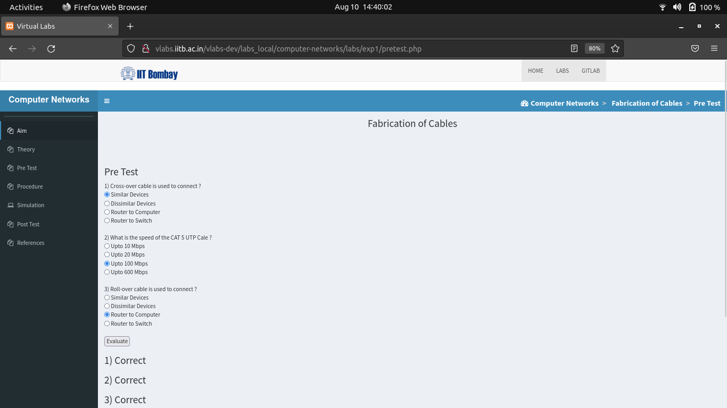
OUTPUT :
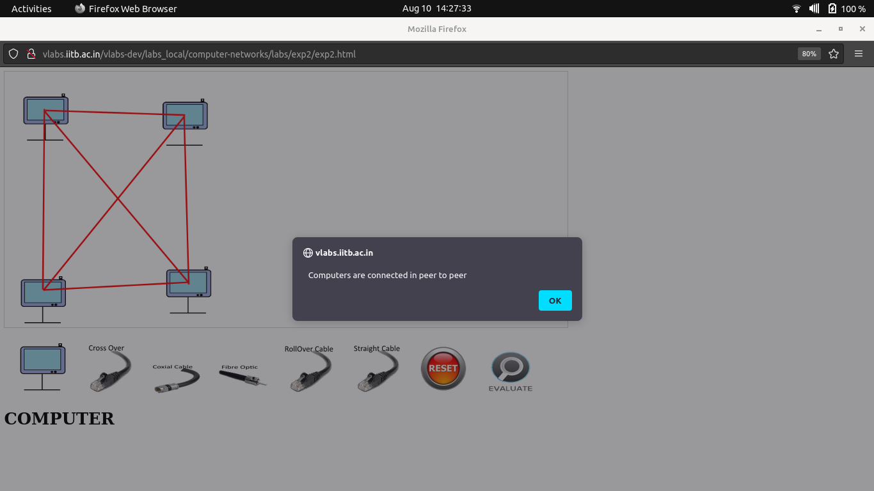

POST TEST:
